January 2016
Dear Parent/ Carer,
School Milk – Cool Milk

We have changed the arrangements for ordering milk for your child to drink in school. Milk orders and deliveries will be now be managed by Cool Milk and you will need to set this up yourselves. The milk is refrigerated and the fridges are supplied to the school by the company.
FAQ’s
How do I register my child for school milk?
Register online (www.coolmilk.com) or complete the paper form at the end of this letter and post yourself to Cool Milk. Soon after this you will receive a payment request.

Do under 5’s still get free school milk?
Yes, free milk will continue until the Friday before your child’s 5th birthday. Send the reply slip at the end of this letter back to school. You also need to register with Cool Milk, who will send you a payment request three weeks before their fifth birthday which will need to be paid if you wish you child to continue to receive school milk.

How much does Cool Milk cost?
Cool Milk costs approximately £15 per term.

How do I pay for Cool Milk?
You can pay either online, over the phone, at a local PayPoint or by cheque in half-termly, termly or annual instalments.
You will need to pay by Tuesday 5pm for your child’s milk to start the following week.

My child is entitled to a free school meal, can they have free school milk too?
Yes, if your child is entitled to statutory free school meals and milk where parental income is below levels stated by Wirral Borough Council. Full information is on the council’s website or phone: 0151 606 2002. Your child must be registered with the council in order for our school to provide the free meal and milk. Additionally if you child is entitled to the statutory free school meal and milk please return the confirmation slip below to the school office.

Yours sincerely,
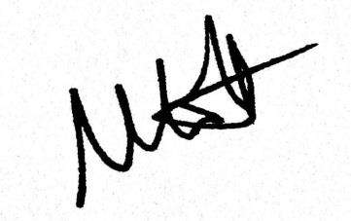
Mr Mark Cotton
------------------------------------------------------------------------------------------------------------------------------------------------------------
Free School Milk - Reply Slip
I would like to request free milk for my child and give permission for the following details to be passed on to our milk supplier, Cool Milk:

Child’s Name: _______________________________ Child’s Class:____________ Child’s Date of Birth:___________
Email address: _____________________________________________________________________________________

Parent’s Signature: ___________________________ Parent’s Name:_______________________________________

Post this page to: FREEPOST COOL MILK (no further address details required)

